**TIBCO Spotfire**

**Desktop Application**

**Documentation**

**Table Of Contents**

1. **Introduction…………………………………………… 2**
2. **Prerequisites……….……………………………….... 2**
3. **How To Install…………….………….……………... 3 - 4**
4. **Usage Guide…………………………………………. 5 - 16**
   1. **Starting Spotfire Desktop App……………………………. 5 - 7**
      1. **Open Existing Analysis……………………………. 6**
      2. **Create New Analysis……………………………….. 7**
   2. **Data Source Connection……….…………………………… 7 - 11**
      1. **Browse Local File………………………………….... 8**
      2. **Connect To Database Server……………………… 8 - 10**
      3. **Viewing Data Canvas………………………………. 11**
   3. **Analysis………...…………..…………………………………. 12 - 14**
      1. **Customizing Analysis……………………………… 13**
      2. **Adding Scripts………………………………………. 14**
   4. **Visualisations………………………………………………… 15 - 16**
      1. **Customizing Visualisations………………………. 16**
5. **References…………….…………….……………….. 17**
   * **TIBCO Cloud Website**
   * **Databases At data.gov.sg**
   * **Official TIBCO Spotfire Documentation**
   1. **Spotfire Scripting Guides……….…………………………. 17**
      * Script Button
      * Refresh Or Reload Data W/ IronPython Script
      * Refresh Every Interval
      * Learn IronPython
      * Spotfire HTML
      * IronPython And JavaScript Refresh

**1. Introduction**

The TIBCO Spotfire Desktop Application is provided to users with the Spotfire Analyst Subscription. Intended to be an exclusive version of Spotfire for Analyst users, The Spotfire App is in every way better and more superior than its web client version counterpart.

It is able to offer more visuals, more functions, APIs, extensions, integrations, customisation, and much more.

**2. Prerequisites**

Before continuing this documentation, it is important that you have a **TIBCO Cloud account created, with a TIBCO Spotfire Analyst Subscription**.

To prevent confusion, you must also read and understood the basic concepts mentioned in the “TIBCO Spotfire Introduction Documentation” report. Documentation mentioned in the introduction will be used in this Spotfire Desktop App documentation.

**3. How To Install**

First, visit the TIBCO Cloud website [here](https://cloud.tibco.com/). When inside the website, **login into your account at the top right corner**. Once logged in, you will be greeted with the TIBCO Cloud Account Homepage.

Inside the TIBCO Cloud Account Homepage will display a plethora of icons. Each icon represents a service provided inside the TIBCO Cloud website. Click on the **Analytics icon then select the TIBCO Spotfire service**.

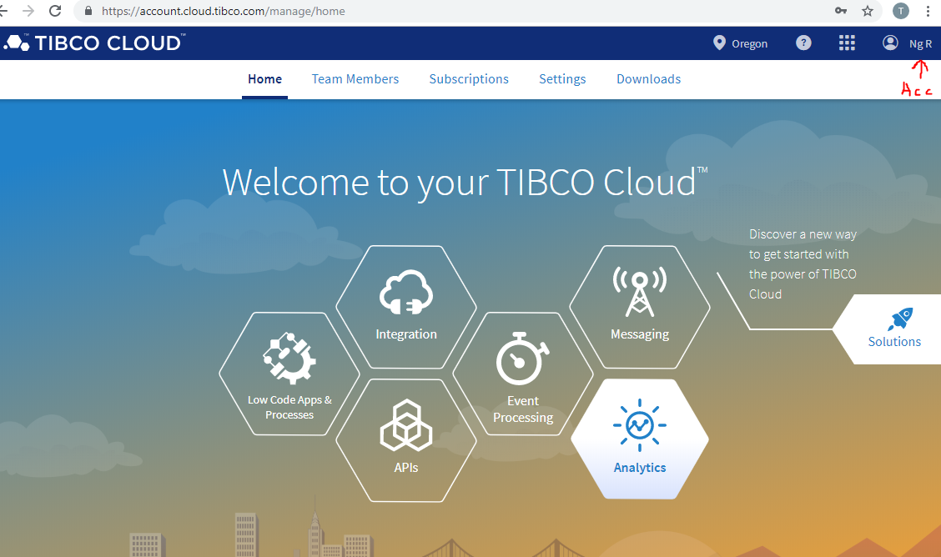

You can also access Spotfire by clicking on the **“Subscriptions” tab, then select “Spotfire”** and launch the application. The website will then redirect you to the exclusive webpages for TIBCO Spotfire web client.

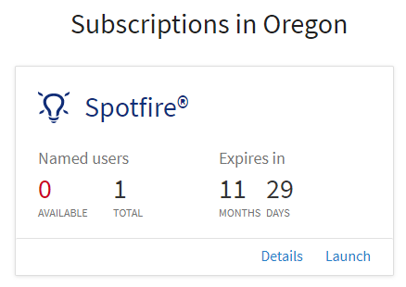

In the Spotfire web client, open up your TIBCO Spotfire Library. The Spotfire Library can be opened at the top left under “Help > Download Spotfire”.

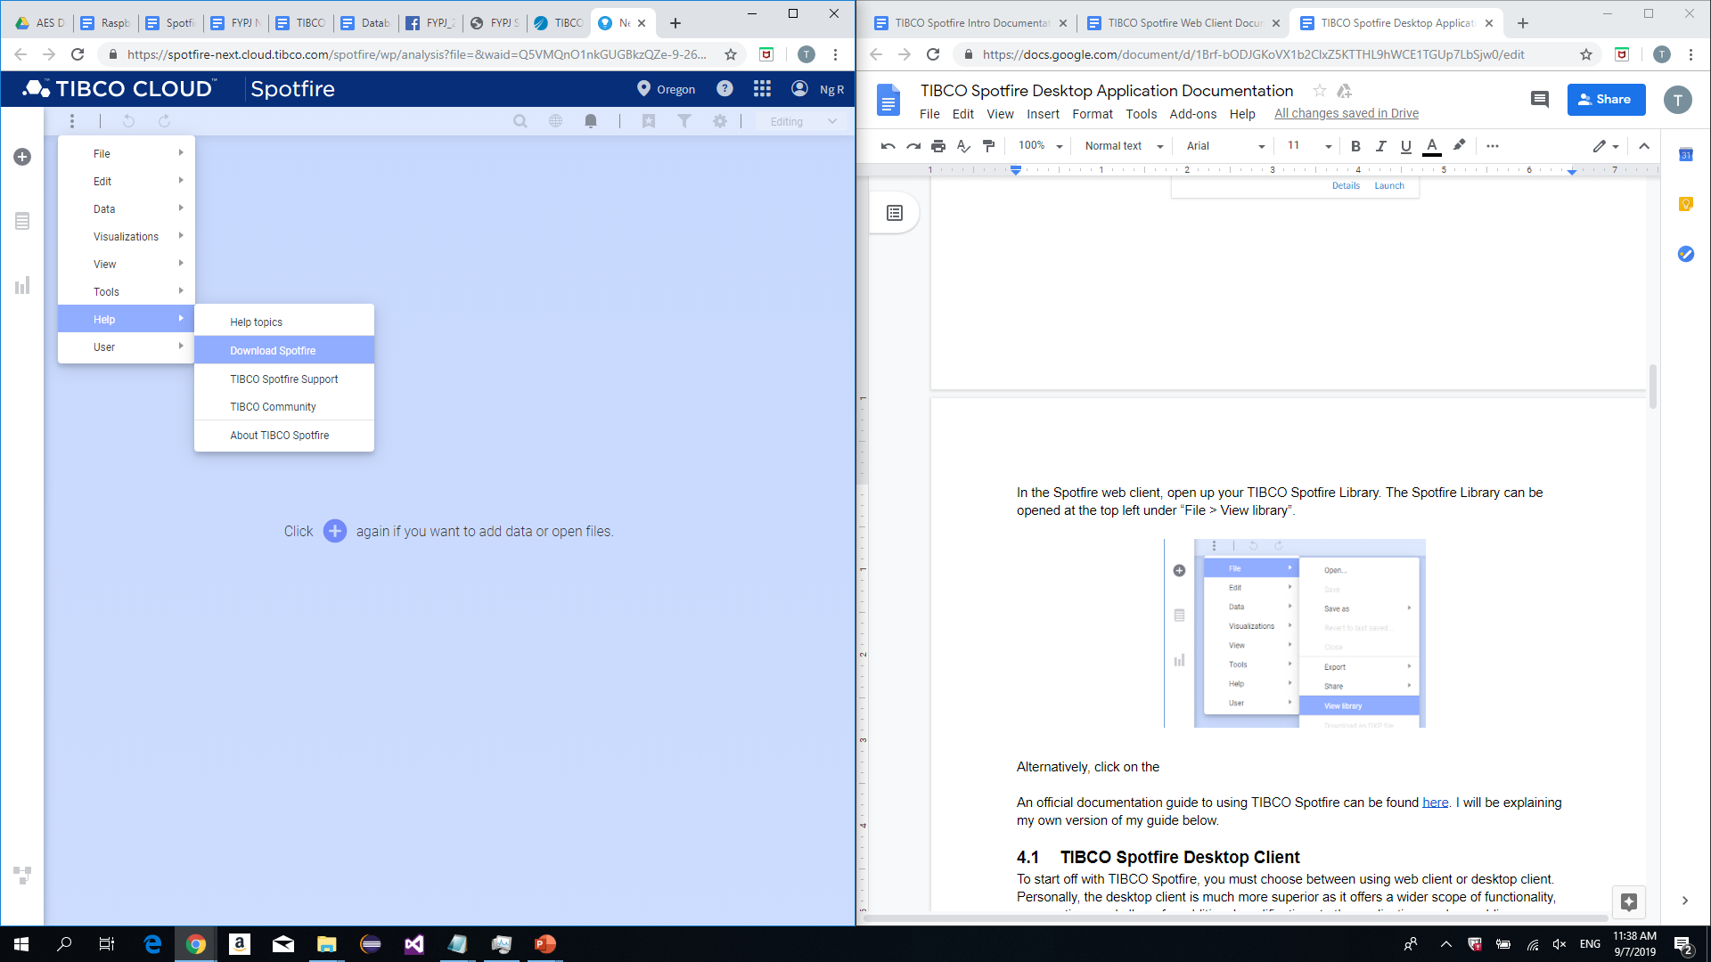

**Alternatively**, click on the tabs icon and open your Spotfire Library, then proceed to download the Spotfire Desktop App.

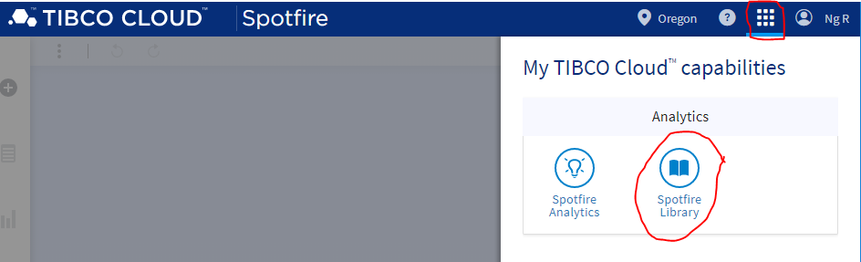

At the download page, will be a single installer download. Download it and let the installer run to setup your Spotfire Desktop Application.

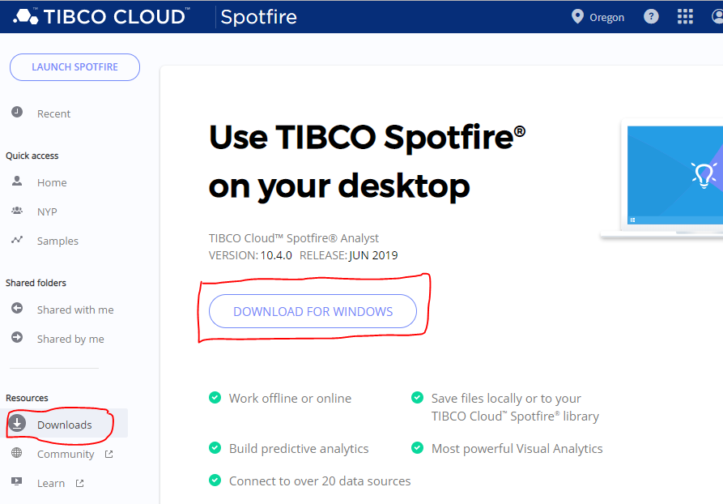

Upon completion, you must use the Spotfire App using your TIBCO account.

**4. Usage Guide**

**4.1 Starting Spotfire Desktop App**

Open your Spotfire Desktop Application. Upon running, a popup will appear with your default web browser. It will prompt you to login to your TIBCO account. Failure to do so will deny access to the Spotfire Desktop Application until logged in.

Once logged, you can close the webpage popup.

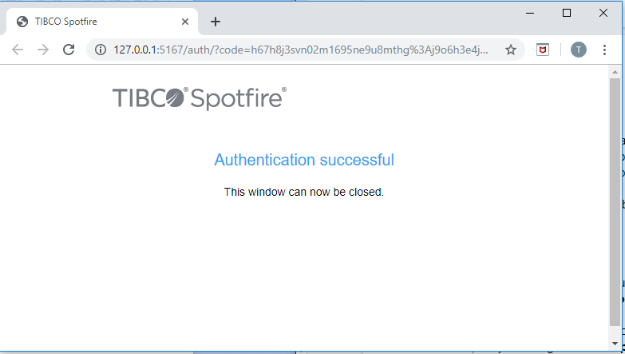

The Spotfire Desktop App will then display this screen.

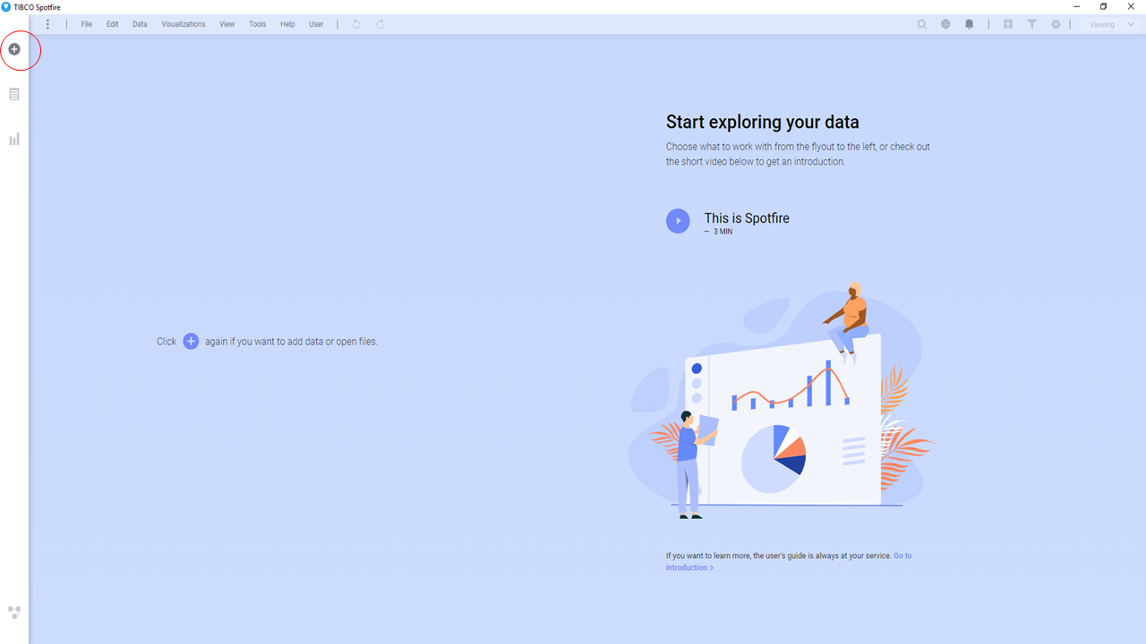

Clicking the “+” button circled red in the previous image, it will prompt you to either create a new Analysis or open an existing Analysis.

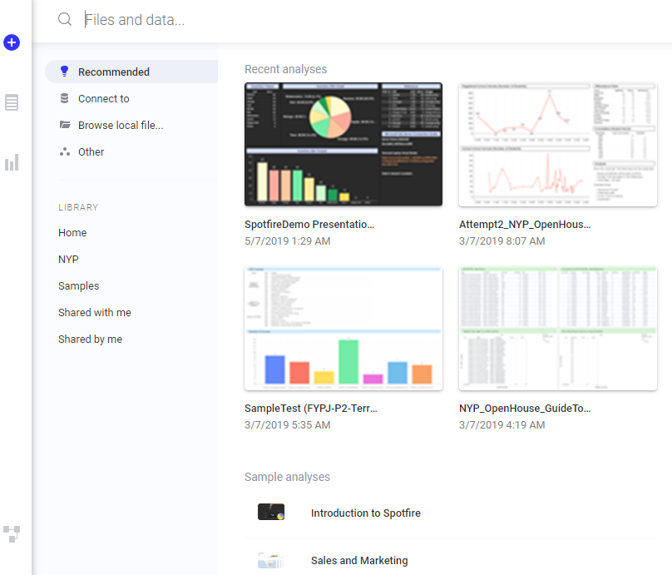

**4.1.1 Open Existing Analysis**

To open an existing Analysis, click on any of the tabs under “**LIBRARY**“. Then, navigate to your existing Analysis and select the Analysis to begin loading.

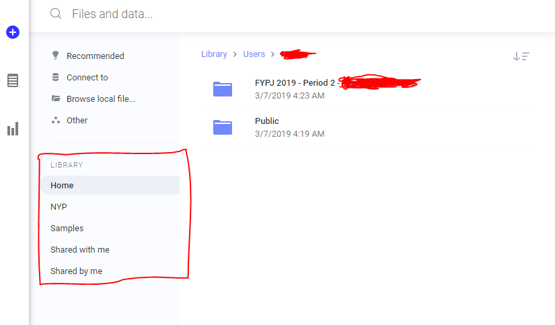

**4.1.2 Create New Analysis**

On the other hand, to create a new Analysis, you must provide a data source by clicking on “Connect to”, “Browse local file…”, or “Other”. Then it will create an Analysis using that data source. You may delete, add, and replace the data source after creating the Analysis.

For creating an Analysis, the Spotfire App will only create it and not save it. To save the Analysis, click at the top left “File > Save as > Library item…”. Then select the directory to save into.

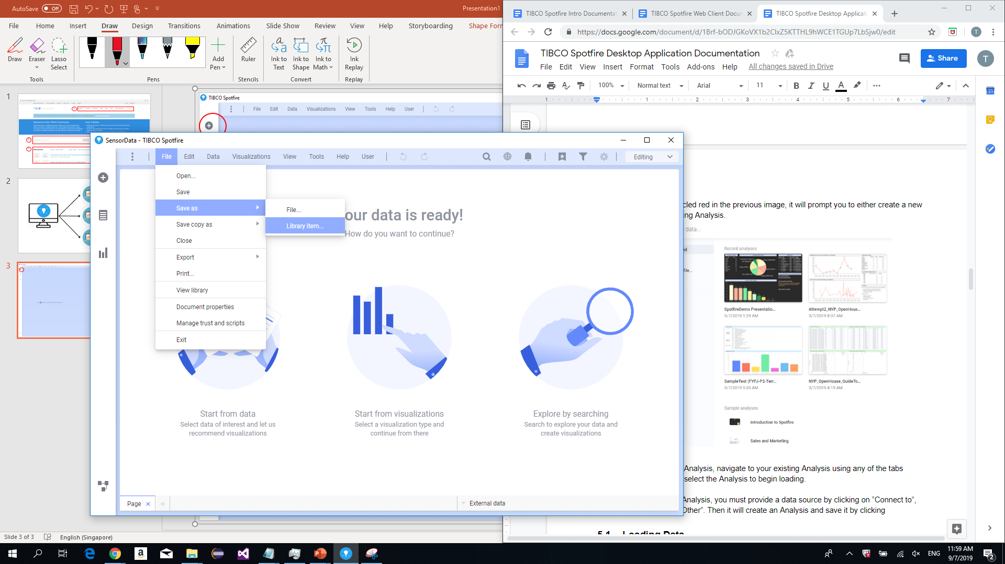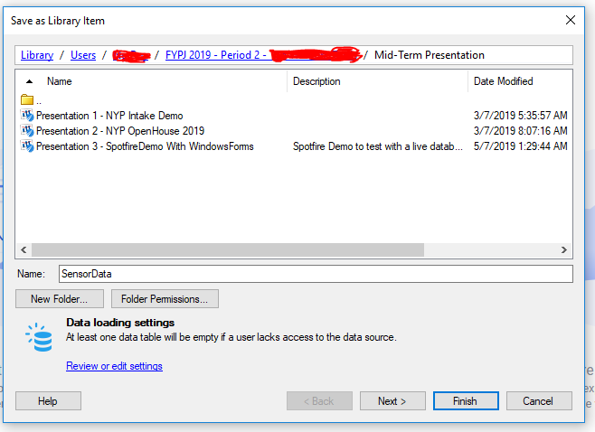

**4.2 Data Source Connection**

Similar steps to creating an Analysis, you must provide a data source from either of the options previously mentioned if you plan to add or replace a data source.



In this section, I will be guiding through the steps on how to add and replace a data source.

**4.2.1 Browse Local File**

By clicking the “+” button, select “Browse local file…”. This option will accept the list acceptable data source file formats. The list can be found in the introduction documentation.

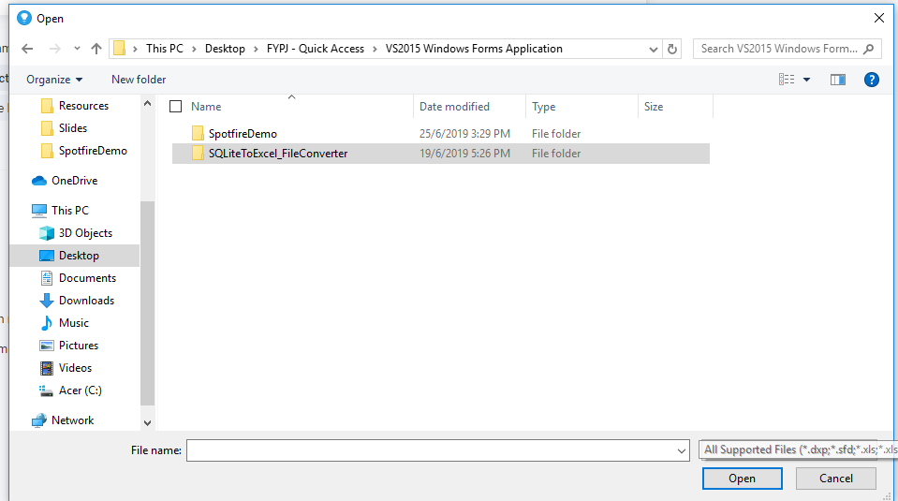

The most easily obtainable file format will be Microsoft Excel Sheets. By using the “Database To Excel App”, you can export any SQL database into an Excel file format. Alternatively, use sample data sources from data.gov.sg.

**4.2.2 Connect To Database Server**

By clicking the “+” button, select “Connect to”. This option will display a list of acceptable database connections. However, not all options are usable, some require additional configuration by installing drivers to enable the database connection.

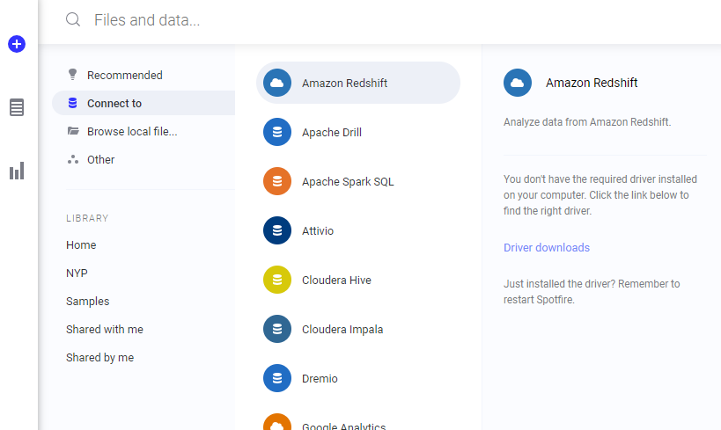

For this “Connect To” guide, I will be using Microsoft SQL Server as a guide. Scroll to Microsoft SQL Server and click on “NEW CONNECTION”

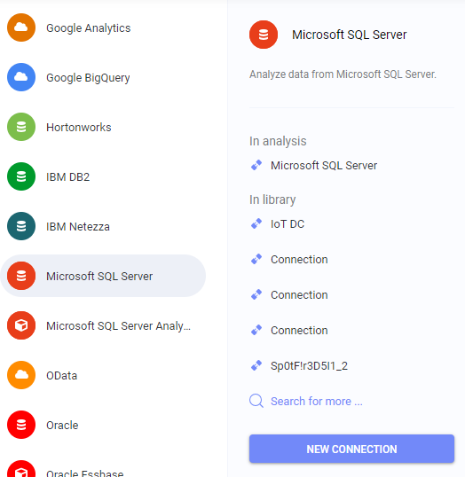

A popup will appear, prompting for a server name. As I am using a local database server, my connection guide might vary when using an online server connection.

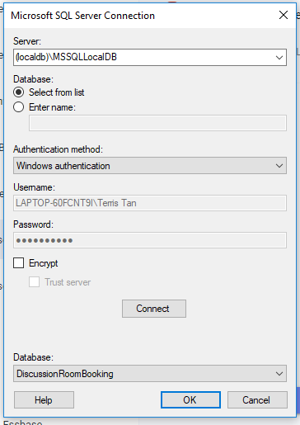

For database connection, ensure to check if your database requires “Encrypt”. Then click on the “Connect” button. After connecting, select the database to be extracted from your database server. Then click “OK”.

Another popup will appear, this will prompt you to configure the connection, selecting which table and what data to be extracted and be used for visualisation.

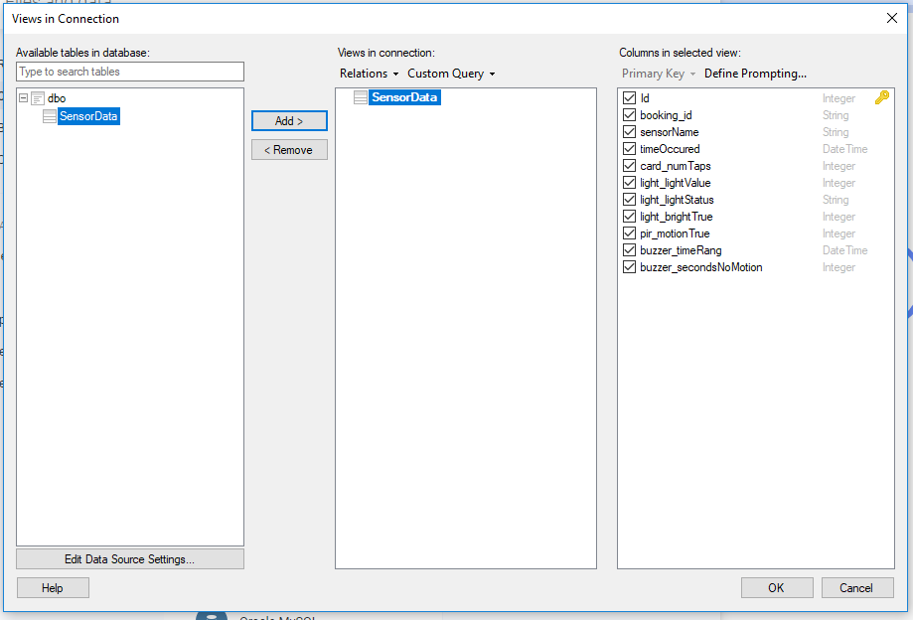

Select the table and press “Add >”, then tick which data column to be extracted into your Analysis. The following will then load.

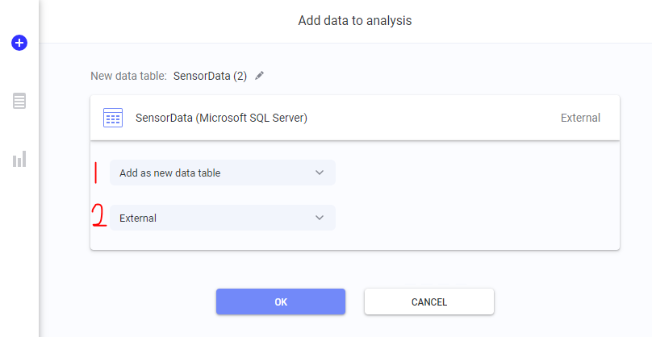

**Section 1:**

Configure the setting to be a new table, or add into an existing table as a new column or new row.

**Section 2**:

How the data will be loaded.

Configure it to:

1. Import (Stored data)
2. On-demand (Data is stored, and updated when requested)
3. External (Always updating.).

Configuring to “External” is recommended as it allows for custom modifications to the data table. You will be able to transform the tables to manipulate data. This allows the creation of new data columns with scripts.

**4.2.3 Viewing Data Canvas**

Regardless of how the data was added, to view your newly connected data source, click on the icon at the bottom left. This will open up your Data Canvas, displaying all data tables internally stored for only this Analysis.

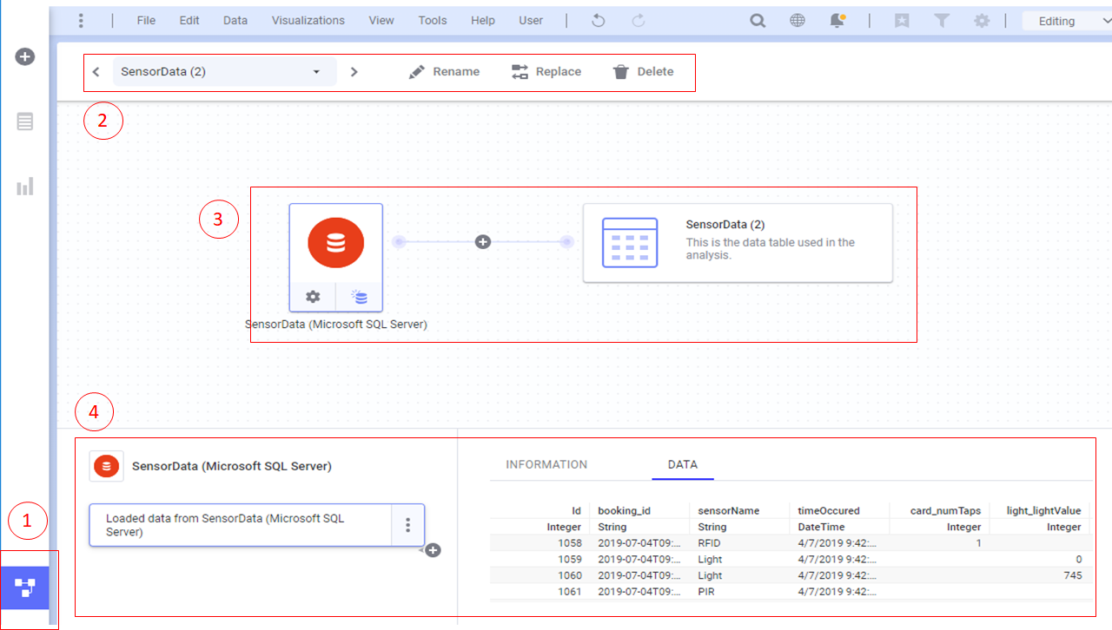

**Section 1:**

The button to open and close the Data Canvas

**Section 2:**

Controls the data table connections. You can select which table to view, rename the table names, replace the data, and remove the data.

**Section 3:**

Displays the Data Canvas of the selected table. Depending on the type, the image above displayed is for “On-demand” data sources, and local stored databases. You are able to further configure the database by using the tools provided. Manipulating the data table columns and rows, and combining the table with another data table, better known as joins.

**Section 4:**

Is an alternate area to manipulate the data table. You can configure the database by changing the settings, change formats and data types, and adding or removing columns. The final display data table will be shown at the right section.

**4.3 Analysis**

When an empty Analysis is created or opened, the following screen will be shown.

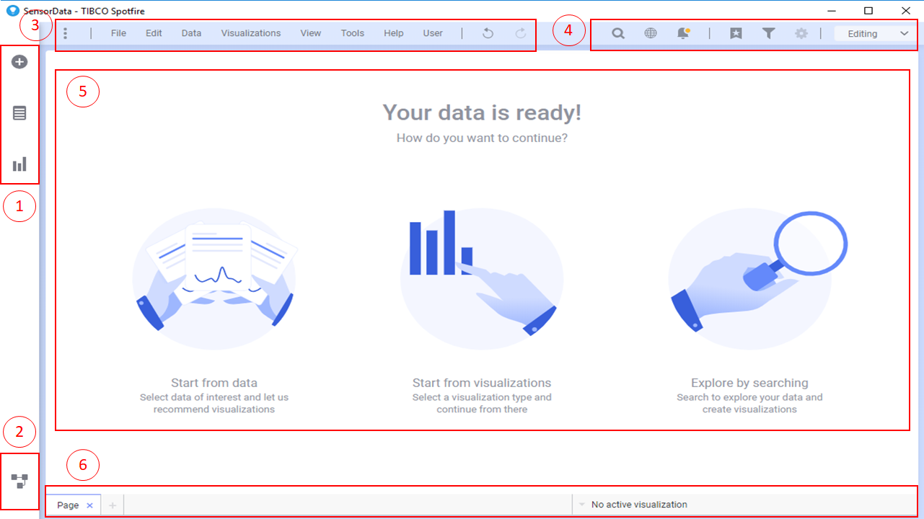

**Section 1:**

Adds a new data table to the Data Canvas, displays all data columns for each table, and displays all available visualisation options Besides adding new data tables, it is mainly used to add visualisations into the current page.

**Section 2:**

Toggles the Data Canvas to be displayed.

**Section 3:**

The menu strip to use most of the features provided for TIBCO Spotfire Desktop App. In the menu strip offers features such as saving, customization, scripts, tools, extensions, and more. It acts as a main menu, with a row a options displayed as a menu strip. It is important to always periodically save your work as Spotfire requires manual saving.

**Section 4:**

It is the second menu strip to perform certain actions, such as search, notifications, reset filters, bookmarks, and changing between edit and view only mode.

**Section 5:**

The main page displaying all visualisations

**Section 6:**

Displays the number of pages for this Analysis. It can be used to add, remove, reposition, and rename the pages of the Analysis

**4.3.1 Customizing Analysis**

At the top left, click on “Visualisations > Canvas styling > Edit custom theme…”. This will allow for customization for the opened Analysis.

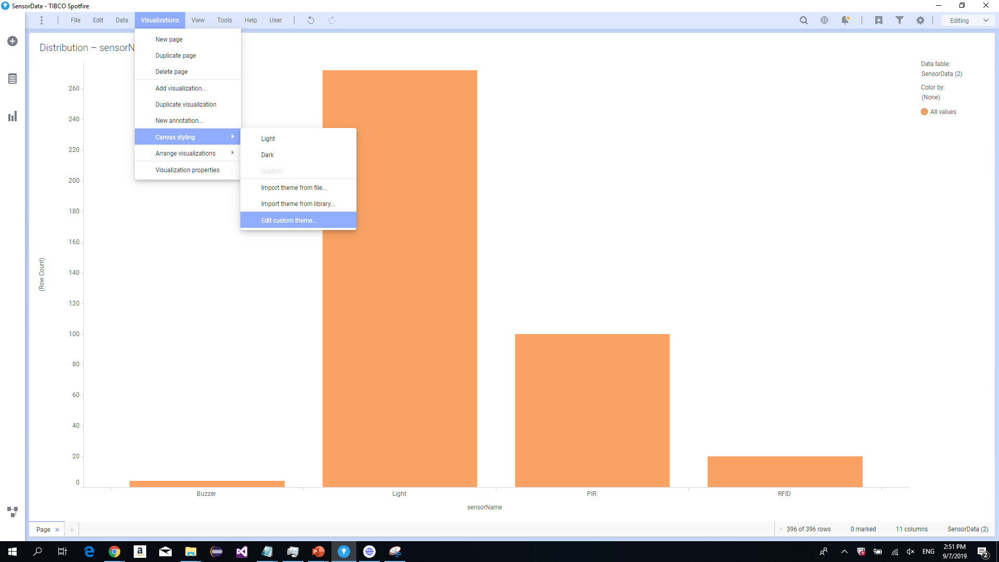

Clicking it will open a menu that allows for many customization options. Such as changing the background color, canvas color, fonts and sizes, label sizes, and more.

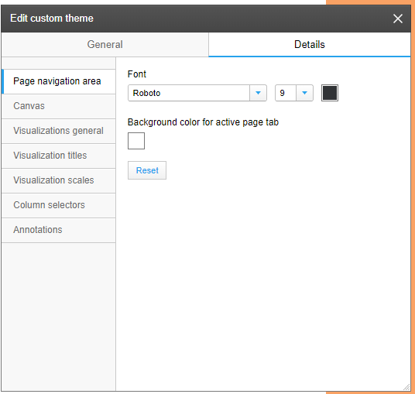

**4.3.2 Adding Scripts**

At the top left, click on “File > Manage trust and scripts”.

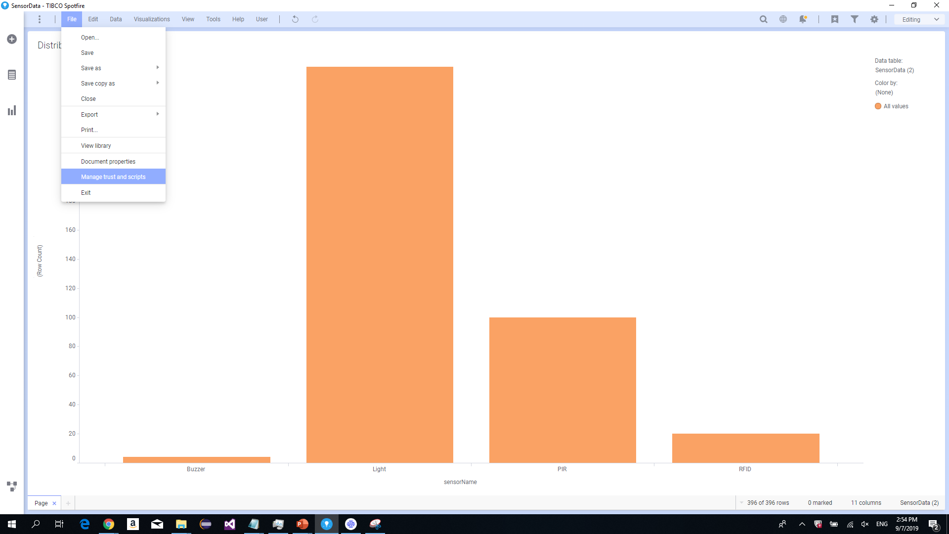

Opening the scripts menu, you can add background scripts and action scripts. These scripts can be used to create interactivity to your analysis and visualisations. However, it requires a strong understanding of programming as there are no compilers to check for syntax errors.

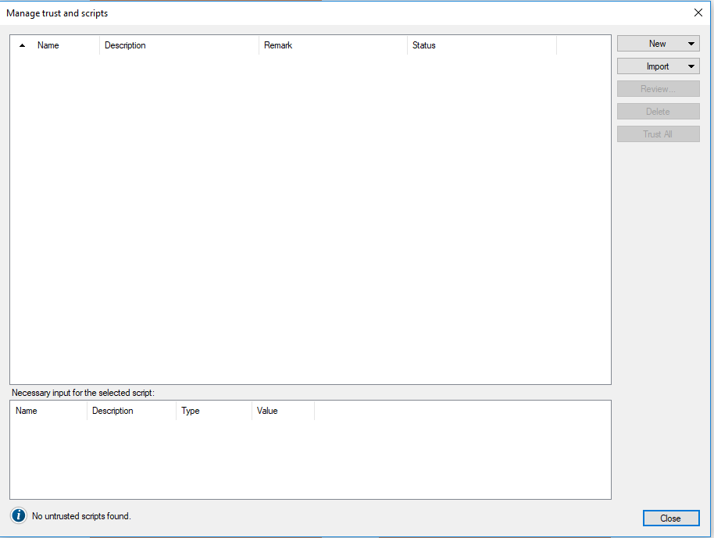

Currently, they have scripts for IronPython, JavaScript, Data function, and Expression function. And requires a good understanding of the syntax to write the codes.

Note: Writing a recursive loop may cause Spotfire App to and crash. Without saving, data will be lost. Refer to References for scripting guides.

**4.4 Visualisations**

The image below displays all available visualizations offered in the Desktop App.

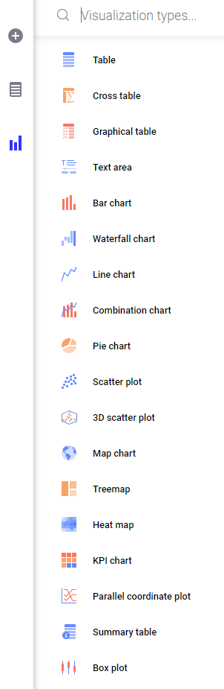

Selecting a visual will immediately create and display it onto the page as shown.

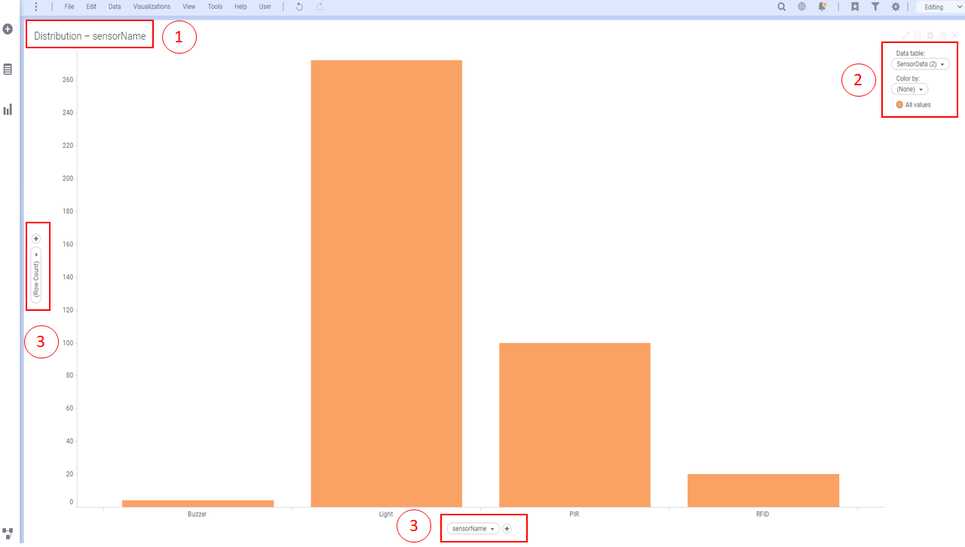

**Section 1**:

Displays the title of the visualisation. Can be renamed, and removed.

**Section 2:**

The legend of the visual. Used to configure which data table to use, and colors of the visual

**Section 3:**

The axis of the visual, used to configure what data is to be displayed. It will be displayed differently for each visualisation, such as a pie chart, KPI, and others more. It can also be used to add custom expressions to create new data columns.

**Right Clicking The Visual:**

Will display a long list of features. Narrowing it, “Visualisation Features” can remove certain parts of the visuals, such as the legend and title. “Property” will allow in depth configuration of the selected visual, and is a common tool used to configure visualisations.

**4.4.1 Customizing Visualisations**

When attempting to customize a single visual, right click and adjust its properties. The following image is a sample of what the properties menu will look like. For every unique visual type, the tabs will be different. This menu tab is for a cross table visual.

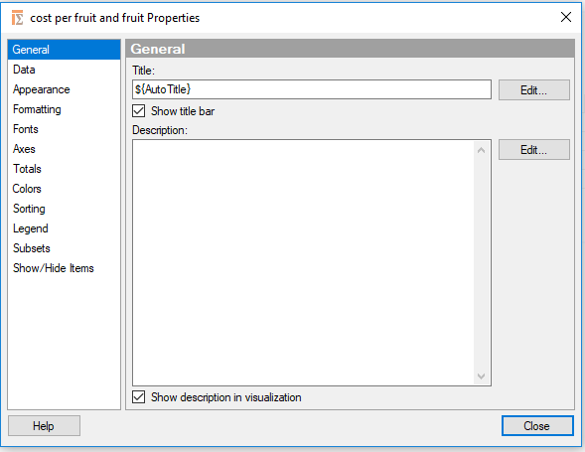

**General** is used to set a title, and an option description.

**Data** is used to configure which data table to be used, and if it allows filtering.

**Appearance** will set the visual lines, such as width of lines, to show cell borders, and more.

**Formatting** allows for formatting of data, such as 2 decimal places for number data.

**Fonts** allows to change the font of each part of the visual, from labels to values.

**Colors** changes the color of the visual. Some visuals offer multiple colors, such as pie charts.

**Sorting** determines how the data will be sorted and viewed.

**Legend** displays what that is to be shown inside the legend tab.

**Show/Hide Items** allows the filtering of specific data, such as hide null values.

There are many other tabs. Each visualisation has their own unique set of tabs in properties. It is best to explore during your own time to get a better understanding of the capabilities of each visualisation.

**5. References**

TIBCO Cloud Website:

<https://cloud.tibco.com/>

Databases At data.gov.sg:

<https://data.gov.sg/>

Official TIBCO Spotfire Documentation:

<http://docs.spotfire.cloud.tibco.com/spotfire/index.html>

**5.1 Spotfire Scripting Guides**

Script Button:

<https://stackoverflow.com/questions/44925626/spotfire-create-button-to-start-loading-data-instead-of-using-load-data-on-dem>

Refresh Or Reload Data W/ IronPython Script:

<https://community.tibco.com/wiki/how-refresh-or-reload-data-using-ironpython-script-tibco-spotfire>

Refresh Every Interval:

<https://community.tibco.com/questions/it-possible-write-script-dashboard-which-will-refresh-one-live-datatable-every-5-mins>

Learning IronPython:

<https://blogs.msdn.microsoft.com/paulcornell/2006/05/31/learning-ironpython-8-the-if-while-and-for-statements-and-array-list-syntax/>

Spotfire HTML:

<https://spotfired.blogspot.com/>

IronPython And JavaScript Refresh:

<https://datashoptalk.com/ironpython-javascript-refresh-tables/>